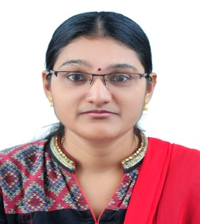
LAKSHMI.C.S

TC 20/2553, SSSRA 23, SS Street,
Karamana, Trivandrum-695 002
Email:cslakshmi.online@gmail.com
Mobile No: +91 8089391929, +91 9447714899

CAREER OBJECTIVE:

To build my career in a progressive organization that will provide me exciting opportunities for professional growth and there by utilize my skills and abilities for the growth of the organization.

ACADEMIC PROFILE:

Institution | Course | University/Board | Year Of Passing
Annamalai University Distance Education | M.B.A Financial Management | Annamalai University | Present
Madha Arts and Science college | B.com | Madras University | 2011
St.John’s Matric. Hr. Sec. School | Hr. Sec. | State Board | 2008
Good Shepherd Matric. School | SSLC | Matriculation | 2006

WORK EXPERIENCE:
- Currently working as Accountant in CADmarC Software Pvt Ltd, Trivandrum.
- Worked as Accounts Assistant in Vijayakumar Associates, Trivandrum.
- Worked as Accounts Trainee in CA Ratheesh & Assocates, Trivandrum.
- Worked as Teacher in Happy Kids, Trivandrum.
- Worked as a Librarian in Sree Maruthi Ram Vidhyamandhir (SMRV), Trivandrum.
- Worked as Assistant Manager in Muthoottu Mini Financiers Pvt. Ltd, Chennai.
- Worked as a XML Converter in SPI Global Pvt Ltd, Chennai.

SKILLSET

- Proficient in Windows OS and Functions
- Proficient in Microsoft Excel, Word and PowerPoint
- Good knowledge in Accounting and Finance operations
PERSONAL DETAILS:

Name : C.S.Lakshmi
Husband name : P.Ramakrishnan
Sex : Female.
Date of birth : 05/10/1990
Nationality : Indian.
Language proficiency : English-write, speak.
Tamil-write, speak,
Malayalam-speak
Marital status : Married
Hobbies : Listening Music, playing.

STRENGTH:

- Smart Working person.

- Flexible and dedicated towards work.

DECLARATION

I consider myself familiar with Financial aspects. I am also confident of my ability to work in a team.
I hereby declare that the information furnished above is true to the best of my knowledge.

Date:
Place: Trivandrum (C.S.LAKSHMI)

